Global MBA Seminar & Workshop

Global MBA Executive Seminars invite executives & academics to speak on their specialist fields or themes and are open to all.

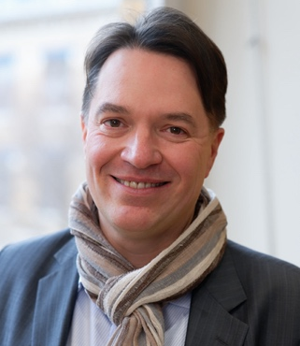
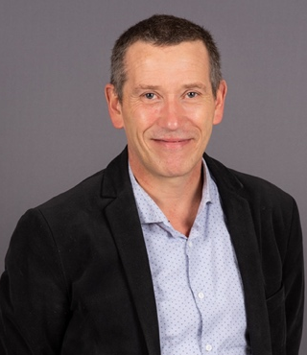
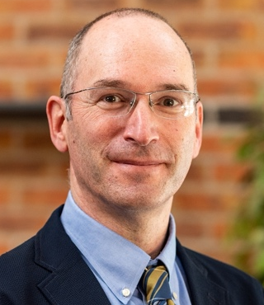

Prof. Jean-Philippe Pierron Prof. Didier Vinot Prof. Philip Sugai

SEMINAR TITLE: Sustainability and Values in Health Organizations
Date: Monday, April 17th
Time: 13：10～14：40 (Presentations)
14：55～16：25 (Discussion, Q&A)
Venue: Presentation Hall (3F)
* Please Sign Up using the signup form as per below, by April 16th, 18:00:
https://forms.gle/Pi8VDXMjyjAGV8nt5

SEMINAR OUTLINE:
In this seminar and workshop, we will have 3 presentations and then an open discussion about values, value and health. First, Prof. Jean-Philippe Pierron, from the Univ. Burgundy, France will explore how we can define sustainability in health, what this means in the general context of aging populations, and the rise of digital technology, and what impact/what reading can we have from the different stakeholders? Then, Prof. Didier from Univ. Lyon 3, iaeLyon Business School will offer managerial answers highlighting some new approaches for the integration of values in health management. Then, Prof. Philip Sugai from Doshisha University will discuss his global value research and its impacts on Health, and the possible applications to health organizations. These presentations will be followed by a Q&A session and open discussions among all participants.

ABOUT Jean-Philippe Pierron: Jean-Philippe Pierron is philosopher, full professor at the University of Burgundy (Dijon, France). He’s specialized in philosphy of living, medicine and care. Former Dean of the faculty of philosophy of Lyon, he’s the scientific director of the Research Chair « Values of Care ». He wrote a dozen of books concerning health, values and humanity.

ABOUT Didier Vinot: Didier Vinot is full professor in Human Resources management at iaeLyon, Business School of the University Jean Moulin in Lyon. Former Vice-President of the university (2011-2020), he’s responsible for the Magellan research groupe in HR, and executive director of the chair « Values of Care ». He published around one hundred articles, publications and books in health management and health organisations.

About Philip Sugai: Philip Sugai is the Director of the Global MBA Program at Doshisha Business School & Director of the Value Research Center. His research focuses on value, value measurement and stakeholder impacts.

